**San Francisco Bay University**

**MATH201 - Calculus-I**

**Homework Assignment #1**

**Due day: 5/27/2023**

**Instruction:**

1. **Push the answer sheet to Github in Word file.**
2. **Overdue homework submission can’t be accepted.**
3. **Takes academic honesty and integrity seriously (Zero Tolerance of Cheating & Plagiarism)**
4. Researchers measured the blood alcohol concentration (BAC) of eight adult male subjects after rapid consumption of *30* mL of ethanol (corresponding to two standard alcoholic drinks). The table shows the data they obtained by averaging the BAC (in mgymL) of the eight men.
   1. Use the readings to sketch the graph of the BAC as a function of *t* in Excel.
   2. Use your graph to describe how the effect of alcohol varies with time.

|  |  |
| --- | --- |
| ***t* (hours)** | **BAC** |
| 0 | 0 |
| 0.2 | 0.25 |
| 0.5 | 0.41 |
| 0.75 | 0.40 |
| 1 | 0.33 |
| 1.25 | 0.29 |
| 1.5 | 0.24 |
| 1.75 | 0.22 |
| 2.0 | 0.18 |
| 2.25 | 0.15 |
| 2.5 | 0.12 |
| 3.0 | 0.07 |
| 3.5 | 0.03 |
| 4.0 | 0.01 |

Answer:

1. A picture containing text, line, plot, number

   Description automatically generated
2. In the graph shown above and also in the excel spreadsheet that is attached with this file, you can see that the BAC(Blood Alcohol Concentration) decreases as the time increases. After the people consumed alcohol the BAC slowly started to decrease. After 1 hour, it decreased and reached around 0.33. After 2 hours it reached around 0.18 and likewise after around 3 hours it reached 0.07. Finally, after 4 hours it reached to 0.01 which is nearly equal to 0.
3. Find an expression for the function whose graph is the given curve in the top half of the circle , and then plot it in Excel or any computer language.

Answer:

For the expression x2 + (y – 2)4 = 4 is y = (4 – x2)1/4 + 2 and the graph for this is:

But the graph for expression x2 + (y - 2)2 = 4is y = (4 – x2)1/2 + 4 and the graph for this is:

1. In a certain country, income tax is assessed as follows. There is no tax on income up to *$10,000*. Any income over *$10,000* is taxed at a rate of *10%*, up to an income of *$20,000*. Any income over *$20,000* is taxed at *15%*.
   1. Sketch the graph of the tax rate *R* as a function of the income *I* in Excel
   2. How much tax is assessed on an income of *$14,000*? On *$26,000*?
   3. Sketch the graph of the total assessed tax *T* as a function of the income *I* in Excel.

Answer:

a) This can be viewed as a piecewise function.

When the income is below or equal to $10,000 then there is no tax i.e. tax rate is 0%. If the income is over $10,000 or equal to $20,000 it has tax rate of 10%. Finally, income over $20,000 has the tax rate of 15%.

R(I) = {

0, if 0 <= I <= 10000

0.1, if 10000 < I <= 20000

0.15, if 20000 < I < infinity

}

b)

T(I) = I R(I) // This is because tax assessed is Income multiplied by tax rate.

T = {

0*I, if 0 <= I <= 10000

0.1*I, if 10000 < I <= 20000

0.15*I, if 20000 < I < infinity

}

T is tax assessed and I is income.

The tax assessed for 14,000 is 1,400 and tax assessed for 26,000 is 3,900.

This is because T(I) = 0.1*I, if 10,000 < I <= 20,000 fits for T(14,000).

Therefore, T(14,000) = 0.1 * 14,000

= 1,400

The tax assessed for $14,000 is $1,400.

Similarly, for T(26,000), the equation T(I) = 0.15*I, if 20,000 < I < infinity fits for T(26,000).

Therefore, T(26,000) = 0.15 * 26,000

= 3,900

The tax assessed for $26,000 is $3,900.

As tax assessed is equal to Income multiplied by tax rate. The equation is the following:

T(I) = I R(I)

T = {

0*I, if 0 <= I <= 10000

0.1*I, if 10000 < I <= 20000

0.15*I, if 20000 < I < infinity

}

T is tax assessed and I is income.

By plotting various values in the excel spreadsheet, we get the following graph.

1. Decide what type of function you might choose as a model for the given data as follows by selecting fitting function in Excel. Of course, before fitting, the x-y values should be created based on your observation.

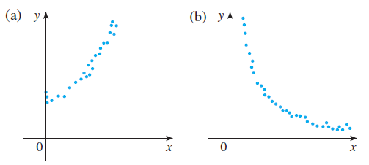

Answer:

1. For this graph we should use a quadratic or a piecewise function. This is because the linear graph would not be able to include all the possible points in the graph. Moreover, there is three values for y while x is zero.

1. For the graph a quadratic function can be used to describe it as the graph looks like asymptote to the x and y axis.

1. Anthropologists use a linear model that relates human femur (thighbone) length to height. The model allows an anthropologist to determine the height of an individual when only a partial skeleton (including the femur) is found. Here we find the model by analyzing the data on femur length and height for the eight males given in the following table.
   1. Make a scatter plot of the data in Excel.
   2. Find and graph the regression line that models the data.
   3. An anthropologist finds a human femur of length *53* cm. How tall was the person?

|  |  |
| --- | --- |
| **Femur length**  **(cm)** | **Height**  **(cm)** |
| 50.1 | 178.5 |
| 48.3 | 173.6 |
| 45.2 | 164.8 |
| 44.7 | 163.7 |
| 44.5 | 168.3 |
| 42.7 | 165.0 |
| 39.5 | 155.4 |
| 38.0 | 155.8 |

Answer:

1. A screenshot of a graph

   Description automatically generated with medium confidence
2. A screenshot of a graph

   Description automatically generated with low confidence

Here is the regression line that models the data. Also, in excel we can find the function which is y = 1.8807x + 82.65.

1. Based on the function y = f(x) = 1.8807x + 82.65 we can find out what the height of the person was.

y = f(53) = 1.8807 * 53 + 82.65 = 182.3271.

So, the height of the person is 182.3271.

1. The table shows the mean (average) distances *d* of the planets from the sun (taking the unit of measurement to be the distance from the earth to the sun) and their periods *T* time of revolution in years).
   1. Fit a power model to the data in Excel
   2. Kepler’s Third Law of Planetary Motion states that "The square of the period of revolution of a planet is proportional to the cube of its mean distance from the sun."
   3. Does your model corroborate Kepler’s Third Law?

|  |  |  |
| --- | --- | --- |
| **Planet** | **d** | **T** |
| Mercury | 0.387 | 0.241 |
| Venus | 0.723 | 0.615 |
| Earth | 1.000 | 1.000 |
| Mars | 1.523 | 1.881 |
| Jupiter | 5.203 | 11.861 |
| Saturn | 9.541 | 29.457 |
| Uranus | 19.190 | 84.008 |
| Neptune | 30.086 | 164.784 |
|  |  |  |

Answer:

a) 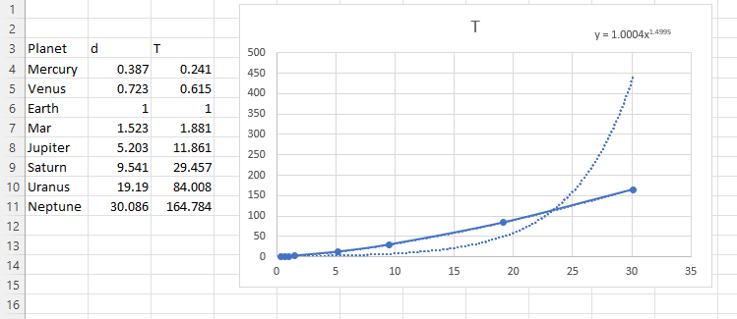

By doing this we get the expression y = 1.0004x1.4995 which is a power model that fits this equation.

1. By squaring in both sides we can get the equation y2 = 1.0008001x2.999.

Here, we can say that 2.999 ≈ 3. So y2 = 1.0008001x3. And according to Kepler’s Law the square of the period of revolution of a planet is proportional to the cube of its mean distance from the sun.

1. My modal corroborate the Kepler’s Third Law as we can see that y2 ∝ x3
2. How is the graph of related to the graph of *f(x)?*
   1. Sketch the graph of in Excel.

I used the given expression and plotted it in excel. I took values in order -360, -358, -356 ….. 358, 360. And the graph is shown above.

* 1. Sketch the graph of in Excel.

I used the given expression and plotted it in excel. I took values from -20, -18 … to 18, 20. And the graph is shown above.

1. Use the given graphs of *f* and *g* to evaluate each expression or explain why it is undefined.
   1. b. c.

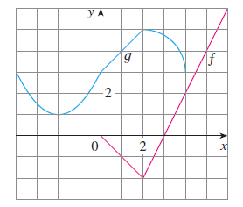

From the graph, it can be inferred that f(x)= |x+2|-2.

And, g(x)=sin.x+3.

So,

1. g(f(6))

=g(|6-2|-2)

=g(4-2)

=g(2)

=sin2+3

=3.90

1. g(g(-2))

=g(sin(-2)+3)

=g(2.09)

=sin(2.09)+3

=3.08

1. f(f(4))

=f(|4-2|-2)

=f(0)

=|0-2|-2

=2-2

=0